Sarah Biggs

Employment Org Design & Talent App
Phase 2

Introduction
In this phase of the project, I designed and queried my database to support the creation of my Employment Org Design & Talent App. I am using the Fake Employee Dataset, sourced from Kaggle (Oyekanmiolamilekan, n.d.). This is all fake data that I had to clean, as described in Phase 1 of the project. In Phase 2, I performed the following steps.
I designed my Neo4j database by cleaning my original data, using python; depositing my cleaned data into my GitHub repository; uploading the data into my Neo4J Aura database with appropriate constraints, nodes, relationships, and attributes, using Cypher; and then finally, developing and testing the appropriate Cypher queries to support the application I’ll build in phase 3 of the project.

1. Conceptual Diagram / Schema
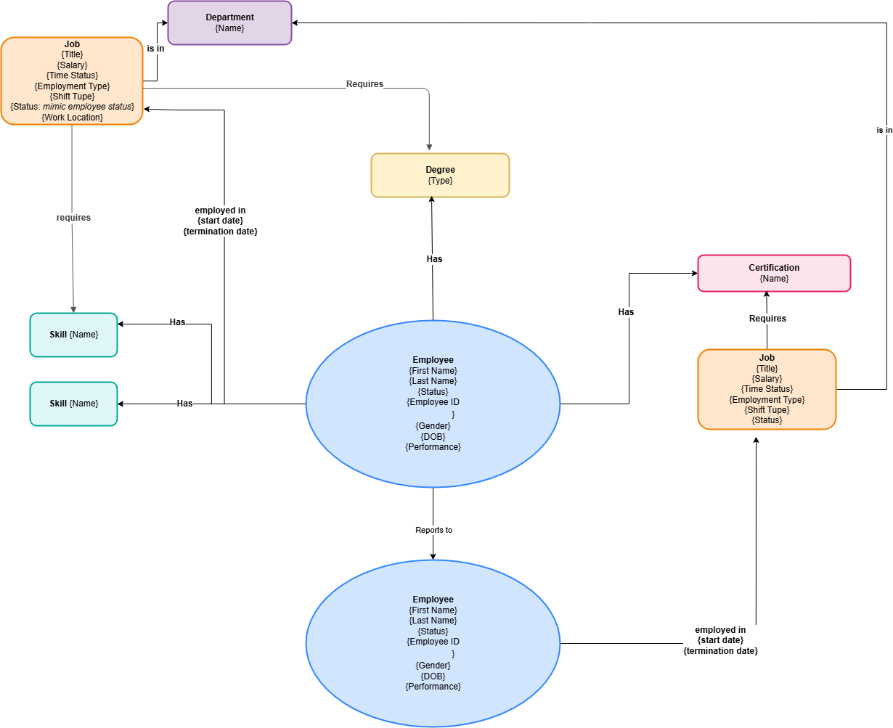
Figure 1
Figure 1 was created using Draw.IO to visualize the basic structure of my database and how the different data elements from my CSV will transfer into a graphic structure. I made the decision that the primary nodes would be Employee, Job, Skill, Certification, Degree, and Department. Each node has at least an ID/name/title/type attribute that is unique. They also have various other attributes that can be seen above. For example, the employee node has attributes, like employee ID, first name, last name, date of birth, gender, performance, status, work experience, and years of service.
Only one relationship type, “Employed_In,” has attributes: start date and termination date. No other relationship types have distinctive attributes.
An image from Neo4j can be seen below as Figure 2. Figure 2 demonstrates the same design as in Figure 1, though it doesn’t list distinctive attributes, beyond the identifier for each node (e.g. employee first name).

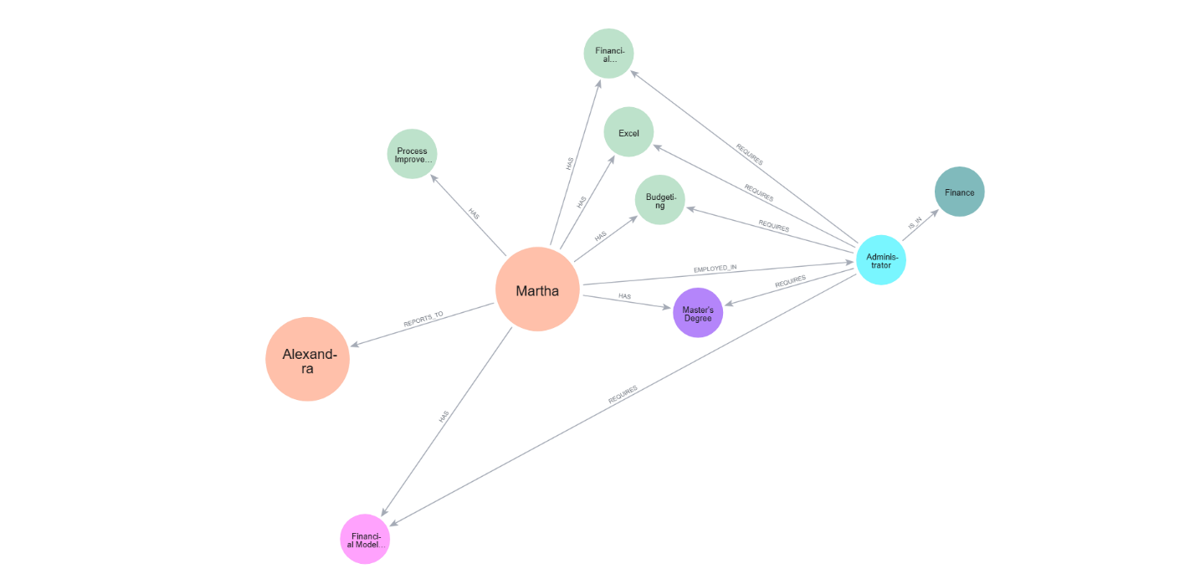
Figure 2
Table 1 below provides more details on each node, edge, and attribute represented in the diagrams above.

Table 1
Element | Node or Relationship | Connection / Direction | Attributes or Properties | Unique Identifier / Notes
Node | Employee | Central node connected to Job, Employee, Skill, Certification, and Degree nodes | Employee ID, first name, last name, date of birth, gender, performance, status, work experience, years of service | employee_id is unique
Node | Job | Connected to Employee, Department, Skill, Certification, and Degree nodes | Position ID, title, salary, time status, employment type, shift type, status, work location | position_id is unique
Node | Department | Connected to Job nodes | Department name | name is unique
Node | Skill | Connected to Employee and Job nodes | Skill name | name is unique
Node | Certification | Connected to Employee and Job nodes | Certification name | name is unique
Node | Degree | Connected to Employee and Job nodes | Degree type | type is unique
Relationship | EMPLOYED_IN | (Employee)-[:EMPLOYED_IN]->(Job) | Start date, termination date | The only relationship type with properties
Relationship | REPORTS_TO | (Employee)-[:REPORTS_TO]->(Employee) | None | Connects an employee to their manager
Relationship | IS_IN | (Job)-[:IS_IN]->(Department) | None | Associates each job with a department
Relationship | HAS | (Employee)-[:HAS]->(Skill) | None | Identifies skills held by an employee
Relationship | HAS | (Employee)-[:HAS]->(Certification) | None | Identifies certifications held by an employee
Relationship | HAS | (Employee)-[:HAS]->(Degree) | None | Identifies degrees held by an employee
Relationship | REQUIRES | (Job)-[:REQUIRES]->(Skill) | None | Identifies skills required by a job
Relationship | REQUIRES | (Job)-[:REQUIRES]->(Certification) | None | Identifies certifications required by a job
Relationship | REQUIRES | (Job)-[:REQUIRES]->(Degree) | None | Identifies the degree required by a job

2. Database Constraints
My database has 6 uniqueness constraints. It didn’t need much more than that. They were added before the data load to limit the load from creating duplicate labels for different types of nodes. For example, there is a limited set of skills, and every employee with that skill will relate to the one skill node with the name attribute being equal to the name of the skill. Additionally, we don’t want duplicate employee records, so each employee node requires a unique employee ID. The list of attributes with uniqueness constraints is: employee ID (employee node), position ID (job node), department name (department node), degree type (degree node), certification name (certification node), and skill name (skill node).
These constraints are important to my database because a user would not want redundant employee data. Additionally, this helps keep the database clean. It’ll be easier to identify all employees connected by a single node of the nodes have uniqueness constraints. This also won’t allow the accidental creation of a duplicate skill if one already exists.

3. Database Creation and Queries
All of the documents for this project will now be in my github repository, linked below. Once in the repository, navigate to the Cypher Code branch. In that folder, you will find two documents, representing the initial upload an design of the database and representing the queries needed for the application.
Link to GitHub Repository: https://github.com/stbiggs26/DatabaseFinalProject2026/tree/main.

4. Overall Contribution Summary
This was an individual project, so I created every aspect of the project myself. I will speak to how I used AI to help in this part of the project, however. I reviewed the AI use applications for this part of the project and understand that it can help with debugging and thought partnering on coding issues but not writing the code/queries directly, pertaining the creation, design, and querying of my database. However, it can be used to perform activities unrelated to what we have learned in this class: cleaning original data based on my original design ideas and (in phase 3) creating the code to develop the application based on my original design ideas (not the cypher code used to query the database but the actual build of the Shiny app).
Therefore, I utilized AI in the following ways in this phase of the project.I partnered with ChatGPT to help debug my cypher codes when I ran into errors. Notably, I based my code ideas, principally, on the LinkedIn Learning Neo4J GitHub content (LinkedIn Learning, n.d.).
Additionally, I used AI to help clean my initial data. Since that was not the main goal of the assignment, I used ChatGPT to help draft a python script, which I reviewed and updated as appropriate, to make the cleaning changes that I outlined in phase 1 of the project.

Sources
LinkedIn Learning. (n.d.). Introduction to Neo4j [GitHub repository]. GitHub. https://github.com/LinkedInLearning/learning-neo4j-2483130
Oyekanmiolamilekan. Fake Employee Dataset. Kaggle, n.d., https://www.kaggle.com/datasets/oyekanmiolamilekan/fake-employee-dataset. Accessed 27 June 2026.

